CST-305: Project 3 – Green's Function and ODE with IVP
Jordan Scott & Angel Velazquez
Responsibilities:
Each team member undertook the calculations for Green's Function and applied Undetermined and Variation of Parameters methods to validate the solutions. Additionally, they collaborated on coding tasks and iteratively refined the code to ensure its functionality.
System Performance Context:
The software executes by initially solving and graphing the Ordinary Differential Equation (ODE). Subsequently, it demonstrates the Green's function method through graphical representation.
Specific Problem:
The particular task addressed involved developing a program capable of solving the homogeneous segment of the differential equation and generating graphical representations of the results for both the ODEs. Furthermore, the program plotted the solution using Green's Function and facilitated a comparison with manually conducted work to ensure accuracy.
Mathematical Approach:
The mathematical approach was using Green’s Function, where
$$G\left(t,s\right)=\left\{0, t<s\right\}\{yH\left(x\right), t≥s$$
And
$$t=s, \frac{d}{dt}g\left(t,s\right) | t=s=1$$
$$y=∫g\left(t,s\right)r\left(s\right)ds$$
Where the integral ranges from 0 to t, r(t) = 0 and g(s,s) = 0

And to verify the work, we would use Undetermined Coefficients as well as Variation of Parameters where it is represented below

Undetermined Coefficients:
$$y_{p}\left(x\right)=A_{1}y_{1}\left(x\right)+A_{2}y_{2}\left(x\right)+…+A_{n}y_{n}\left(x\right)$$
Where $A_{1}, A_{2}, A_{n}$are arbitrary multiplicative constants and follows one of three cases

Case 1:
$ϴ\left(x\right)= p_{n}\left(x\right)$ an nth degree polynomial in x

$$y_{p}=A_{n}x^{n}+A_{n-1}x^{n-1}+…+ A_{1}x+A_{0}$$
Case 2:
ke^{αx} where k and α are known constants

$$y_{p}=Ae^{αx}$$
Case 3:
$ϴ\left(x\right)= k_{1}sinβx+k_{2}cosβx$where k₁, k₂, and $β$ are known constants
$$y_{p}=Asinβx+Bcosβx$$

Variation of Parameters:
L(y) = ϴ(x) has the form
$$y_{p}=v_{1}y_{1}+v_{2}y_{2}+…+v_{n}y_{n}$$
Where
$$y_{h}=c_{1}y_{1}\left(x\right)+c_{2}y_{2}\left(x\right)+…+c_{n}y_{n}\left(x\right)$$
In order to find v we need to solve for v’
$${v'}_{1}y_{1}+{v'}_{2}y_{2}+…+{v^{'}}_{n}y_{n}=0$$
$${v'}_{1}{y'}_{1}+{v'}_{2}{y'}_{2}+…+{v^{'}}_{n}{y'}_{n}=0$$
$${v'}_{1}y_{1}^{(n-2)}+{v'}_{2}y_{2}^{(n-2)}+…+{v'}_{n}y_{n}^{(n-2)}=0$$
$${v'}_{1}y_{1}^{(n-1)}+{v'}_{2}y_{2}^{(n-1)}+…+{v'}_{n}y_{n}^{(n-1)}=0$$

If n = 3 we would use:
$${v'}_{1}y_{1}+{v'}_{2}y_{2}+{v'}_{3}y_{3}=0$$
$${v'}_{1}{y'}_{1}+{v'}_{2}{y'}_{2}+{v^{'}}_{3}{y'}_{3}=0$$
$${v'}_{1}{y''}_{1}+{v'}_{2}{y''}_{2}+{v^{'}}_{3}{y''}_{3}=ϴ(x)$$
If n =2:
$${v'}_{1}{y'}_{1}+{v'}_{2}{y'}_{2}+{v^{'}}_{3}{y'}_{3}=0$$
$${v'}_{1}{y''}_{1}+{v'}_{2}{y''}_{2}=ϴ(x)$$
And if n=1
$${v'}_{1}y_{1}= ϴ(x)$$

Approach for implementation in code:
Certainly! This code implements a numerical integration approach alongside Green's function method to solve two second-order ordinary differential equations (ODEs). The first ODE, \( y'' + 4y = x \), and the second ODE, \( y'' + y = 4 \), are defined with initial conditions. Using SciPy's `solve_ivp` and `odeint` functions, the solutions for both equations are computed and plotted against time. Additionally, the Green's function approach is employed, where systems of equations representing each ODE are defined. These systems are then solved numerically for various \( x \) values, allowing the calculation of Green's function values. The obtained Green's functions are then visualized by plotting them against \( x \) using Matplotlib. This comprehensive approach provides a detailed exploration of the solutions to the differential equations through both numerical integration and Green's function methodology.

Screenshots:
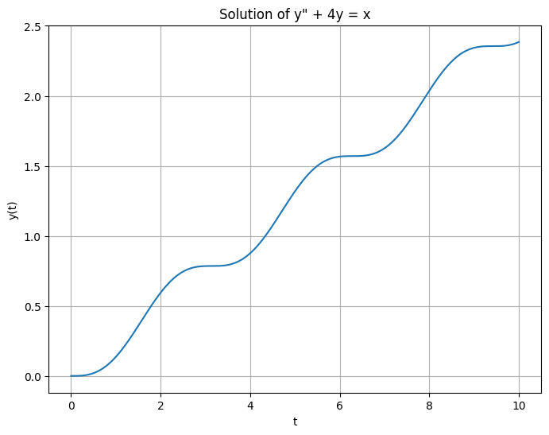
Plot of ODE of y’’ + 4y = x
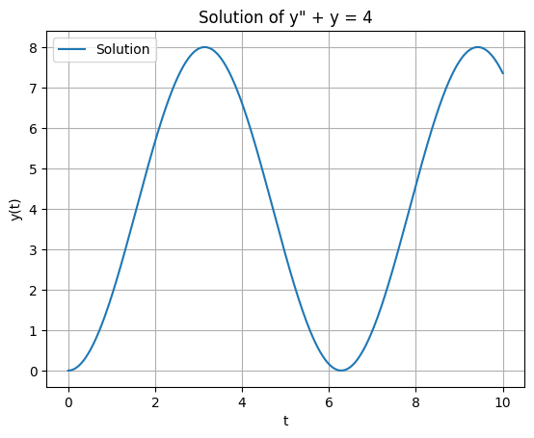
Plot of ODE of y’’ + y = 4
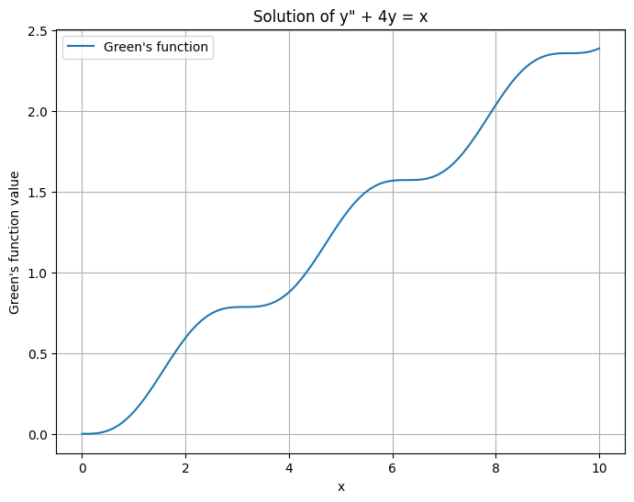
Plot of Green’s Function for y’’ + 4y = x

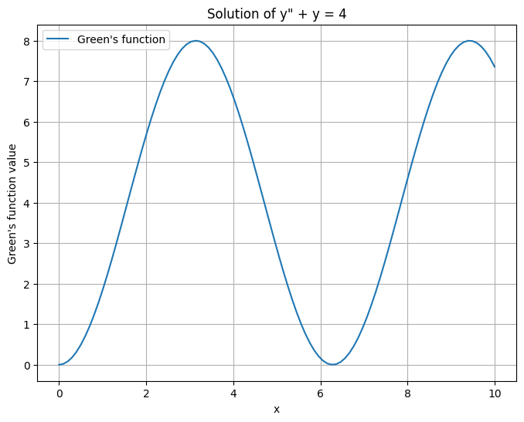
Plot of Green’s Function for y’’ + y = 4
Part 1: Solve two ODEs using the Green’s function. Then you are to compare the Green’s function solution to the one obtained by using the two methods covered in class, that is, The Undetermined Coefficients: “Simple Form of the Method” and “The Variation of Parameters”. Solve both ODEs manually using Green’s function and both methods as well. Compare both results. They should be the same. The assigned ODEs are:
- $y"+4y=x;y(0)=y'(0)=0$

- $y"+y=4; y(0)=y'(0)=0$

Equation 1: $y"+4y=x;y(0)=y'(0)=0$

Undetermined Coefficients: Initially, we determined the homogeneous solution, finding imaginary eigenvalues, prompting the use of the general formula for case 2. The particular solution, yp(x), was identified as a polynomial falling under case 1, taking the form A2x^2 + A1x + A0. Deriving the first and second derivatives of yp(x), we substituted them into the original equation, equating it to F(x), which was x. Solving for the coefficients A2, A1, and A0, we found that yp(x) equaled ¼*x. Our final y(x) combining the homogeneous and underdetermined parts was expressed as c1cos(2x) + c2sin(2x) + ¼*x. To determine c1 and c2, we substituted initial values, obtaining c1=0. Further, taking the derivative and substituting the initial value yielded c2=-1/8. Converting to the variable t, the final equation became y(t)= –1/8sin(2t) +1/4t.

Variation of Parameters: Once again, we began by determining the homogeneous solution, following case 2, and then applied the principle of superposition, expressing y(x) as c1y1(x) + c2y2(x). Utilizing the equation v'1y1 + v'2y2 = Θ(x), we substituted and derived v’1 and v’2, facilitating the integration to obtain v1 and v2. By virtue of the principle of superposition, yp(x) is represented as v1y1(x) + v2y2(x), resulting in ¼x, which leads to the expression c1cos(2x) + c2sin(2x) + ¼*x for y(x). This form mirrors the previous solution, resulting in y(t) = –1/8sin(2t) +1/4t.
Green's Function: Once again, we derived the homogeneous solution (case 2) and proceeded with the principle of superposition, yielding C1y(x) + C2y2(x). Employing Green's function, we set g(s,s) = 0, allowing us to determine C1 by substituting s. Next, we found the partial derivative with respect to t and equated it to one, substituting C1 to find C2. By substituting C2 into the equation for C1, we obtained its value. Integrating from y = ∫g(t,s)r(s)ds from 0 to t, where r(s) = f(x) = x and g(t,s) = C1y1(x) + C2y2(x), resulted in –sin(2s)cos(2t)/2 + cos(2s)sin(2t)/2. This precisely led to the solution y(t) = -sin(2t)/8 + 1/4t.

Overall, all three methods would produce the same answer.

Equation 2: $y"+y=4; y(0)=y'(0)=0$

Undetermined Coefficients: Initially, we determined the homogeneous solution, leading to imaginary eigenvalues and prompting the use of the Case 2 general formula. Concurrently, the particular solution, yp(x), followed case 1 as a polynomial, taking the form A2x^2 + A1x + A0. After obtaining the first and second derivatives of this polynomial, we substituted these functions into the original equation, setting it equal to F(x), which was 4. Upon finding the values of A2, A1, and A0, we obtained yp(x) = 4. After solving for both the homogeneous part and yp(x), our expression for y(x) became c1cos(x) + c2sin(x) + 4. Next, we solved for c1 and c2 by substituting initial values, resulting in c1 = -4, and then utilized the derivative of y(x) to find c2 = 0 when plugging in the initial value. Consequently, the final equation derived as y(t) = 4(1 - cos(t)).

Variation of Parameters: Once again, we begin by identifying the homogeneous solution, which has already been determined, and then apply the principle of superposition, expressing y(x) as c1y1(x) + c2y2(x) where:

v'1y1 + v'2y2 = Θ(x)

This equation is utilized to derive v'1 and v'2, followed by integration to determine v1 and v2. Upon analysis, we find that yp(x) takes the form v1y1(x) + v2y2(x), resulting in 4. Consequently, we obtain the expression c1cos(x) + c2sin(x) + 4 for y(x). By following this method, we arrive at the same solution: y(t) = 4(1 - cos(t)).

Green’s Function: Initially, we determine the homogeneous solution (already established) and apply the principle of superposition, yielding c1y1(x) + c2y2(x). Subsequently, we utilize Green’s Function, setting g(s,s) = 0 and substituting s to determine c1. By deriving the partial derivative with respect to t and setting it to 1, and then substituting c1, we obtain c2. Further, substituting c2 into the equation for c1 yields its value. Integrating y=∫g(t,s)r(s)ds from 0 to t, where r(s)=f(x)=x and g(t,s)= c1y1(x)+c2y2(x), we arrive at the expression 4(cos^2(t) – cos(t) + sin^2(t)), which simplifies to y(t) = 4(1-cos(t)).

Overall, all three methods would produce the same answer.
All the math work for both equations will be include inside the zip file.
Github Repo: https://github.com/angel-vlzqz/Modeling-and-Simulation/tree/main/projects/project%203%20CLC

